An online event management and matchmaking system for board game clubs

Contents

Planning and Preparation 2
Background 2
The problem 2
The goal 2
The proposed solution 2
Components 3
Skills and resources 3
Infrastructure 3
Risks 3
Schedule 3
Work Completed 5
Literature 5
Development Environment 5
Reflection 7
References 9
Appendix A 10
Appendix B 11

Planning and Preparation

Background
I am an avid board gamer and am a part of a local group that meet weekly in a pub for games, plus other ad hoc meet ups. The weekly evenings starts at 7.30 when there is a roll call of members saying which games they have brought. Once all the games are mentioned, people suggest games to play and form and join groups.

The problem
It's only a community group but we can easily get 50-60 people every week, essentially taking over the pub. This means that the roll call is chaotic with people not hearing games mentioned or not knowing what they are, as portrayed by the images in Appendix A. Some people started to use Facebook to pre-arrange games with some using the polling feature. The polling feature has its issues (such as difficult use on mobile devices) and other non-Facebook users feel left out. There is also a problem of new people finding the whole roll call intimidating and some people end up without a group.

The goal
The goal of this project is to create a method of creating groups and matchmaking players at the start of the night to avoid the chaos of the roll call and to improve the overall experience of the night, making it more inclusive and friendly. It should allow games to begin sooner, extending the time available in the night for members to enjoy themselves. It would support the organisation of pre-arranged and recurring games, as well as games set up on the night.

The proposed solution
My intention is to create a website to allow members to list games that they have available on a particular night and to register interest in playing certain games on that night. The system would display information about those games, such as a description and the number of players, etc. This would allow members to pre-arrange games and learn more about those games before playing. Later, there would also be the option of more advanced matchmaking methods such as game and player preferences, random games, or skill-based matching. On the night, members would see the list of available games on a big screen in the venue and could register interest in them at that point or add their own games, using their own device or by speaking to another member with access to the website. Once interested members have settled on a game (or had the system arrange it), they join their table and start the game. Remaining members will easily be able to see what other games are still available to play and with who.
The system would also integrate with the group’s website and social media, sharing details of proposed and arranged games. This would allow new and non-members to be more informed at the start of the night, as well as promoting the events to the public. At a meeting with the user group, this proposal was confirmed by the group leader, as seen in Appendix B.
Utilising my personal and professional knowledge of web development with HTML and JavaScript and expanding upon my level 3 Open University studies in Developing concurrent distributed systems (M362), Ebusiness technologies: foundations and practice (T320) and Fundamentals of interaction design (M364), I intend to develop a multi-tiered, distributed web application which is accessible on a range of devices and by a range of users.
This description has not changed very much except to clarify the solution.

Components
The system can be broken down into four main components:
- User Management – account settings and game preferences
- Event Management – recurring and ad hoc events, e.g. “Tuesday evenings”
- Game/Library Management – collections of available games in the group
- Match Management – the actual games being arranged & played

Risks and Schedule
An updated risk table is available in Appendix C. In particular, I have recently had trouble keeping up with the schedule of work. This highlighted the real impact (High) and likelihood (High) of risk R9 due to requirements of other OU study and an increased workload at work from starting a new job. I have also included a new risk R15, because of the unexpected time involved in non-work related activities such as the needs of family and friends, as well as illness over the Easter period. The initial schedule was far too optimistic and rigid, when it should be flexible. These problems have caused several items on my schedule to be delayed or rearranged.
For planning and management, I am using Project in a Box Planner software, which includes a Gantt chart visualisation of the schedule and also Risk and Issue logs. This is because the package is free and includes brief project management guides for various types of project, from simple to complex. The package is also easy to use but still much more usable and powerful than other free project management tools and templates, such as GanttProject.
I have not, yet, completed the Risk and Issue logs within the software, as I have been waiting to complete the first prototype before liaising more with the client and formalising the risks, requirements and actions.
Below, is an updated Gantt chart of the schedule and a breakdown can be found in Appendix D.
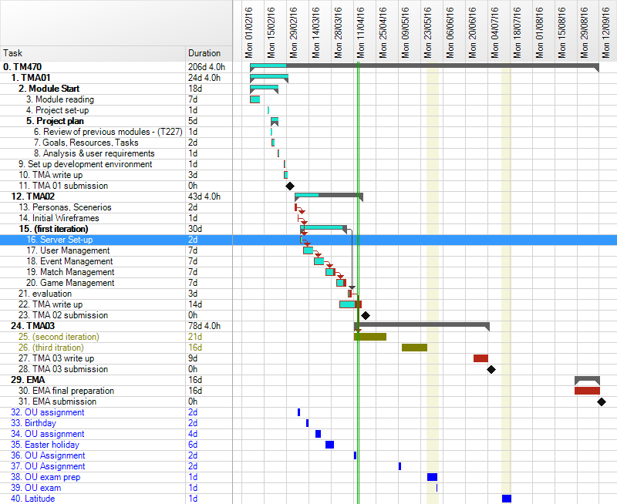

Method
I have also not, yet, utilised any aspects of the Agile development methodology, due to my initial prototype (and first iteration) taking much longer than initially planned. Now that the prototype is completed, I will be able to meet with the user group to discuss requirements and prepare User Stories and Personas, in order to focus development in line with the requirements.
I still think that an iterative model is suitable for this project, where all elements of the project are included from the start but are refined throughout.

Infrastructure
In order to make the final application as user-friendly and efficient as possible, I have decided to adopt a Model-View-Controller architecture, where the Model is a representation of the data that a user sees and interacts with, the View is how the user sees that data and is updated by the Model, and the Controller is the business logic which manipulates the data, i.e. the Model.
The idea is to separate presentation logic from business logic and presentation state, so that the logic and the presentation can be altered independently without affecting the other. This has the benefit of efficient design in terms of development – the entire codebase does not need to change to change either the logic or the presentation.
I have decided to use the AngularJS framework for this purpose because of its simple HTML-expanding design rather than complicated templating engines, which means I do not need to learn even more new languages. Angular actually expands on the capabilities of the Controller and View to enable better user interactions and usable code. This has resulted in it being referred to as MVW, “Model-View-Whatever works for you” (Minar, 2012) because it enables a diverse range of methods to interact with the Model and View, not restricted to Controller types. Angular provides sophisticated but simple data binding between the View and the Model.
To expand the View component, I have decided to also use JQuery, which is a JavaScript library designed to simplify client-side manipulation of HTML. It is strongly supported by Angular and is widely used on the internet.
Also, to speed development of prototypes, I am using the Bootstrap library, which includes HTML, CSS and JavaScript templates to create consistent websites very quickly.
As the Model component, I have decided to use a Node.js server to host the application and act as the service layer of the Model to interact with the database. Using Node allows me to finely control access to the data and provide secure business logic. Node is developed in JavaScript, which also means that I am using existing skills rather than learning new languages. Node also has an extensive catalogue of packages which can be easily installed and automatically updated.
For persistence, I have decided to use an online database service, Orchestrate.io, in order to explore the benefits and pitfalls of wider distributed web services. Using a database as a service also means that I do not have to be concerned with the maintenance or scaling of resources, as these are managed by others. The database is considered to be a JSON NoSQL store, which means that data is stored in JavaScript object documents rather than relational tables with rows. This is in order to improve the ease of accessing the data and to reduce the complexity of the database. Again, Using a JavaScript database means that all the development is in a single main language and all systems are naturally compatible.
On top of the Node server, I have decided to use the Express.js web server framework, which allows simple servers to be set up extremely quickly and easily. It handles the routing of HTTP requests, errors and cookies & sessions. Using Express in this set-up means that there is a wide range of established practices and tutorials, which will speed up development.
I would also be using another external data source, BoardGameGeek.com, which has many details about almost every published board game in existence and provides an API to access that data.
The Controller component is mainly handled by Angular so that much of the business logic is provided by the client. The server (part of the Model) also handles some business logic, in order to provide security around the data, which is provided via a RESTful API. This means that the client and the server are separated and that it is possible for different clients (perhaps developed by others) to utilise the same server API to access the same data but use that data in different ways. A separation of data and how that data is used.
In my application, the API will be accessed via AJAX calls directly to the API, which means that data can be retrieved and manipulated in the background without affect the user’s interaction with the application. Emphasising a client-based application with AJAX also means that less data has to be sent and received between server and client because the presentation information is handled separately and only the required Model data is transferred. This improves the responsiveness of an application, which will be critical to the success of my project.

Project Work Completed

Literature
In addition to the previous books, I have been using JavaScript Patterns by Stoyan Stefanov (2010) as a very good reference, particularly for working with JSON and asynchronous events. Stefanov is an engineer at Yahoo!, one of the world’s largest services. As the entire application architecture is JavaScript-based, it is important that I learn best practices for the more intricate aspects of the applications, such as the API development and AJAX communication. The text is accessible and obviously written by somebody passionate about clarity and understanding.

Initial Prototype
Work on the initial prototype was very slow as I was really trying to develop a reduced first iteration of the product than an actual prototype. This work began with setting up the server software and starting to develop the API.
Setting up the web server, itself, was extremely easy using the Express framework and it allows relatively easy development of APIs with its simple routing middleware. I set up the server to deliver static files, such as HTML, Javascript and images located in the /public/ folder from the root URL, e.g. www.example.com/index.html when the file is stored at /public/index.html. I then routed calls to /api/ to the specific controller to handle API requests. The client-server nature of the application means that the static files could be on a different server, which is actually a good way of improving performance because the it means requests *****. However, for the sake of development, I have included them on the same server. The /api/ prefix allows it to be obvious if a request is for the API or for a static file/client-side route.
To begin my testing and learning of the architecture, I installed the BoardGameGeek API Node package and created a simple API endpoint, /api/bgg/user/:username, to retrieve user information. This example uses the basic example included with the package (Montes, 2016):
router.get('/bgg/user/:username', function(req, res, next) {
var options = {
timeout: 5000,
retry: {
initial: 100,
multiplier: 2,
max: 15e3
}
}
var bgg = require('bgg')(options);
bgg('users', {name: req.params.username})
.then(function(results){
res.send("Name: " + results.user.firstname.value + " " + results.user.lastname.value);
console.log(results);
});
});
The res.send() method is a part of the Express framework and sends an HTTP response with the appropriate headers and content. In basic usage, a String is sent and a response code of 200 (OK) is assumed. Without a client application to receive this response, the browser displays the content, depending on the browser.
This work well straight away and I felt very positive about the decision to implement an API.

***work on API and front-end
***logging
***work on bgg api search

Reflection
***other OU work
***work
***tiredness
***getting stuck on authorisation… downfalls of plugins
Reflection after Action:
- What went well? What can I learn from that for the rest of my work on this module?

- What didn’t go so well? How did I recover from my problems? What can I learn from that for the rest of my work on this module?

- Have I reached an acceptable standard, both according to what the module team and my tutor have told me and according to my own judgement?

- Have I met the learning outcomes for this piece of work?

- If not, what am I going to change?

References

(Minar, 2012)
Stoyan Stefanov (2010)
Appendix A
Images of venue at roll call.
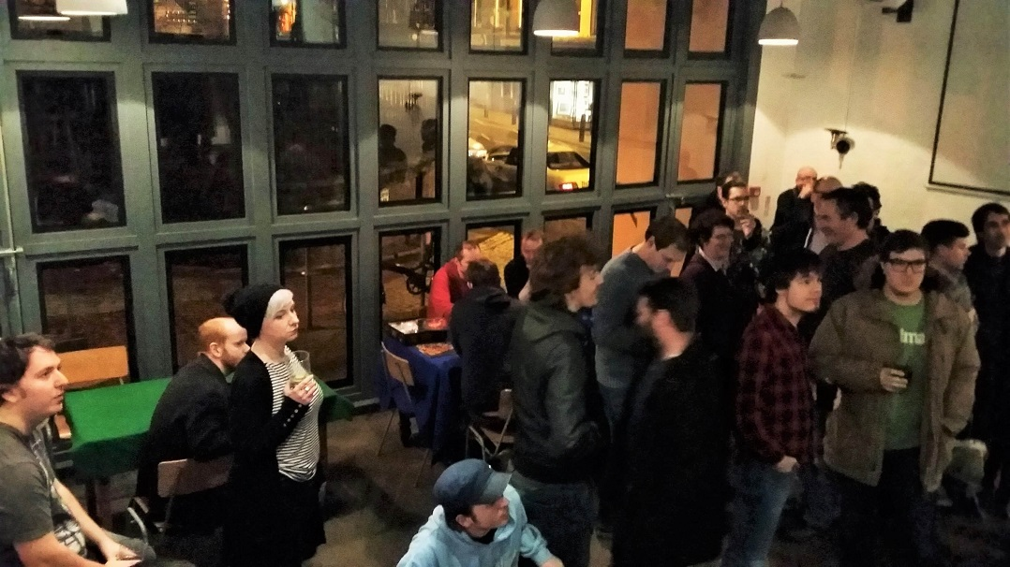

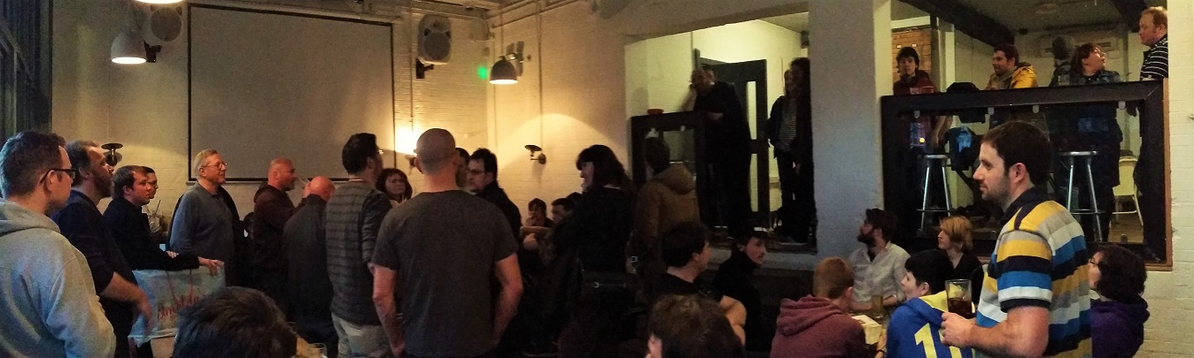

Appendix B
Verbatim comments from discussions with a few core members of the user group.
John, Group Leader:
“Jarryd is making the app as part of his Uni work - and the scope is somewhat up to him, however...
The app needs to address several problems. And when you get into it, there's a lot of user requirements, issues and yada for our group. There's a balancing act of allowing people to organise tricky to get to table games with known players and also being welcoming to new people and not just having a cliquey Youre Not From Around Here cold shoulder thing going on, AND addressing social anxiety issues, and unfamiliarity, and yada yada yada. ( Headache ).
But basically game organising that is -
1) Inclusive of *everyone*. Particularly new people and those who want least fuss.
2) Allow good organisation of pre-arranged games.
3) Allow good organisation of games on game night.
Also the point of all this is to let the system / computer do the management. If someone is having to babysit a process it's a failure.
All you really need is a central list of available games, and people can vote on what they want to play. The particulars of that list break down into pre-arranged games, so games that go up on a list before game night. And then games that turn up adhoc on game night and are visible to everyone - either via their mobile device, OR, and here's the kicker, available through a large public display.
Ideally what you want is an app that allows a given user to keep a record of whatever games they have. Flag them to be pre-arranged or not. Or flag them as games I am bringing with me this week. Voting to play a game is as simple as clicking on a game in the list, which will mark you as voted, and on game night when the process is resolved, the system will tell you what you're playing based on a bunch of voting weights.
On game night the whole thing should be available from a large public display ( via hooking any device up to a chromecast ) - which allows new people to see whats available to play as well as those who dont buy into the app process to still interact with whats going on.
Effectively you move game organising into an on screen digital space. To the refuseniks or new it will be better than a roll call - no having to shout what you have or failing to hear what others have. To those who do buy into it they will get a way to browse whats available AND - cool thing - be able to read what a game actually is if they dont know ( which is most of the time ) via a click.
As for being available for other gaming groups, yeah, sure, very possible in theory. Development is somewhat Jarryds thing atm as he's doing it to fulfill course requirements. So. It may or may not be a workable prototype. Plus theres an issue of user buy in - if no one is interested its not going to work out, but, casting it onto a big screen guarantees its at least somewhat fit for purpose as it will replace a game roll call.”
Pete
“The interface and experience is key to user buy-in and acceptance – nothing should be complicated or time-consuming. The app should be able to take a user’s secret preferences of other players to play with or avoid. “

Appendix C
Updated table of risks with High impact and High or Medium likelihood risks in bold and updates highlighted in grey.
# | Risk | Importance / Impact | Likelihood
R1 | Client does not accept the final product | H | L
R2 | Client accepts product but there is little or no use of product | H | M
R3 | Product does not work as intended | H | M
R4 | Infrastructure fails (such as host or database) | H | L
R5 | Cost of infrastructure is prohibitive | M | L
R6 | Project scope becomes unmanageable | M | M
R7 | Chosen frameworks become unavailable | M | L
R8 | Chosen frameworks are more difficult to learn than expected | H | M
R9 | Other unexpected OU study or work impacts availability | H | H
R10 | Conflict between users over project requirements | H | H
R11 | Lack of cooperation from users | M | L
R12 | Unclear or incorrect requirements | M | M
R13 | Lack of access to game information from external resource | M | L
R14 | Unable to use projector in venue | L | L
R15 | Other unexpected time requirements, such as illness, holidays, or family & friend needs. | H | H

Appendix D
Work Breakdown Schedule of tasks
ID | WBS Code | Name | Start | Finish | Duration | % Complete
0 |  | TM470 | 06/02/2016 | 12/09/2016 | 206d 4.0h | 10.4
1 | 1 | TMA01 | 06/02/2016 | 01/03/2016 | 24d 4.0h | 100
2 | 1.1 | Module Start | 06/02/2016 | 24/02/2016 | 18d | 100
3 | 1.1.1 | Module reading | 06/02/2016 | 12/02/2016 | 7d | 100
4 | 1.1.2 | Project set-up | 17/02/2016 | 17/02/2016 | 1d | 100
5 | 1.1.3 | Project plan | 19/02/2016 | 24/02/2016 | 5d | 100
6 | 1.1.3.1 | Review of previous modules - (T227) | 19/02/2016 | 19/02/2016 | 1d | 100
7 | 1.1.3.2 | Goals, Resources, Tasks | 19/02/2016 | 21/02/2016 | 2d | 100
8 | 1.1.3.3 | Analysis & user requirements | 23/02/2016 | 24/02/2016 | 1d | 100
9 | 1.2 | Set up development environment | 27/02/2016 | 28/02/2016 | 1d | 100
10 | 1.3 | TMA write up | 27/02/2016 | 29/02/2016 | 3d | 100
11 | 1.4 | TMA 01 submission | 01/03/2016 | 01/03/2016 | 0h | 100
12 | 2 | TMA02 | 05/03/2016 | 17/04/2016 | 43d 4.0h | 35
13 | 2.1 | Personas, Scenerios | 05/03/2016 | 06/03/2016 | 2d | 0
14 | 2.2 | Initial Wireframes | 07/03/2016 | 07/03/2016 | 1d | 0
15 | 2.3 | (first iteration) | 08/03/2016 | 06/04/2016 | 30d | 90
16 | 2.3.1 | Server Set-up | 08/03/2016 | 09/03/2016 | 2d | 100
17 | 2.3.2 | User Management | 10/03/2016 | 16/03/2016 | 7d | 100
18 | 2.3.3 | Event Management | 17/03/2016 | 23/03/2016 | 7d | 100
19 | 2.3.4 | Match Management | 24/03/2016 | 30/03/2016 | 7d | 80
20 | 2.3.5 | Game Management | 31/03/2016 | 06/04/2016 | 7d | 70
21 | 2.4 | evaluation | 07/04/2016 | 09/04/2016 | 3d | 50
22 | 2.5 | TMA write up | 02/04/2016 | 16/04/2016 | 14d | 70
23 | 2.6 | TMA 02 submission | 17/04/2016 | 17/04/2016 | 0h | 0
24 | 3 | TMA03 | 11/04/2016 | 05/07/2016 | 78d 4.0h | 0
25 | 3.1 | (second iteration) | 11/04/2016 | 01/05/2016 | 21d | 0
26 | 3.2 | (third itration) | 11/05/2016 | 27/05/2016 | 16d | 0
27 | 3.3 | TMA 03 write up | 25/06/2016 | 04/07/2016 | 9d | 0
28 | 3.4 | TMA 03 submission | 05/07/2016 | 05/07/2016 | 0h | 0
29 | 4 | EMA | 27/08/2016 | 12/09/2016 | 16d | 0
30 | 4.1 | EMA final preparation | 27/08/2016 | 12/09/2016 | 16d | 0
31 | 4.2 | EMA submission | 12/09/2016 | 12/09/2016 | 0h | 0
32 | 5 | OU assignment | 07/03/2016 | 08/03/2016 | 2d | 0
33 | 6 | Birthday | 12/03/2016 | 13/03/2016 | 2d | 0
34 | 7 | OU assignment | 18/03/2016 | 21/03/2016 | 4d | 0
35 | 8 | Easter holiday | 24/03/2016 | 29/03/2016 | 6d | 0
36 | 9 | OU Assignment | 11/04/2016 | 12/04/2016 | 2d | 0
37 | 10 | OU Assignment | 09/05/2016 | 10/05/2016 | 2d | 0
38 | 11 | OU exam prep | 27/05/2016 | 02/06/2016 | 1d | 0
39 | 12 | OU exam | 02/06/2016 | 02/06/2016 | 1d | 0
40 | 13 | Latitude | 13/07/2016 | 19/07/2016 | 1d | 0
List of Git commits.
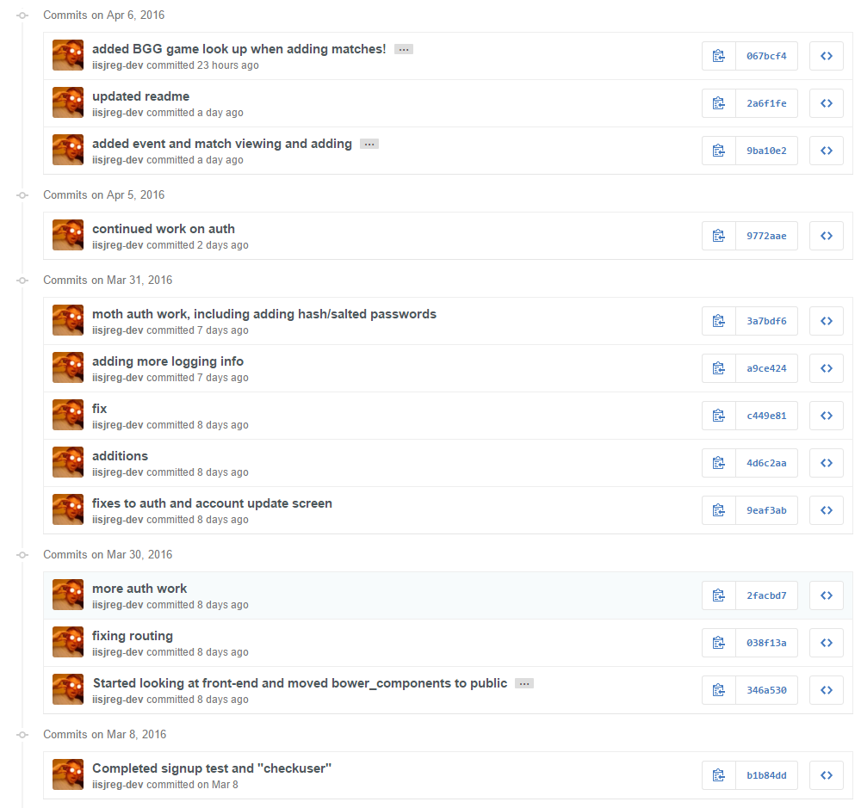
…/cont’d
